Data Collected using microseconds(1 second=1000000 microseconds)

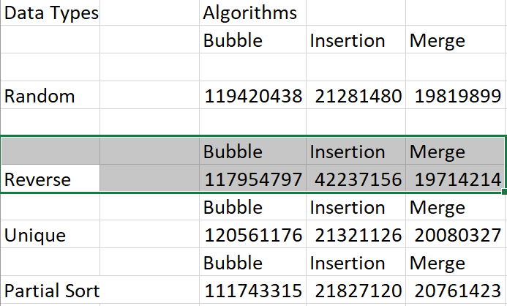

After calculating the time for all the algorithms across each Data Set for 100,000 integers the results were pretty much as expected. Bubble Sort was by far the slowest every time no matter the dataset. Insertion for the most part clocked slightly slower than Merge except for the Reverse data set, where Merge beat it by 22522942 microseconds. It would seem Merge is better at handling more swaps as a data set that is reversed would require the most swaps and “sorting” out of all the other data sets. Overall, it seems that the fastest sorting algorithm is Merge Sort, with Insertion sort being a little slower, and finally Bubble being far slower than the two others.